S3 Auto Copy Demo

To Begin with the Lab

Summary of the Lab
In this lab, the Amazon Redshift S3 Auto Copy feature was configured to automatically load files from Amazon S3 into a Redshift table whenever new files were uploaded. A preview-mode Amazon Redshift provisioned cluster was created because S3 Auto Copy was available only in preview clusters. An S3 bucket and folder were configured as the source location, and a sales table was created as the target table. A COPY job with AUTO mode enabled was then created to monitor S3 events and load matching files automatically. Finally, multiple sales files were uploaded to S3, and system tables were queried to verify that the files were loaded successfully into Redshift without manually running COPY commands.

Understanding Amazon Redshift S3 Auto Copy
Normally, data engineers upload files to Amazon S3 and manually execute COPY commands to load data into Amazon Redshift. This process works well but becomes inefficient when files arrive continuously throughout the day.
Amazon Redshift S3 Auto Copy solves this problem by automatically monitoring an S3 location and loading newly uploaded files into a target Redshift table. Once the auto copy job is created, Redshift listens for S3 events and triggers data loads automatically.
Example:
Consider an e-commerce company receiving sales files every hour from multiple stores. Instead of running COPY commands 24 times a day, an Auto Copy job watches the S3 folder. Whenever a new sales file arrives, Redshift automatically loads the data into the sales table, ensuring dashboards and reports always contain the latest information.

Lab Steps
Create a Redshift Cluster
- Sign in to the AWS Management Console
- Navigate to Amazon Redshift
- Open the Provisioned Clusters Dashboard
- Click Create Cluster
- Enter a cluster name
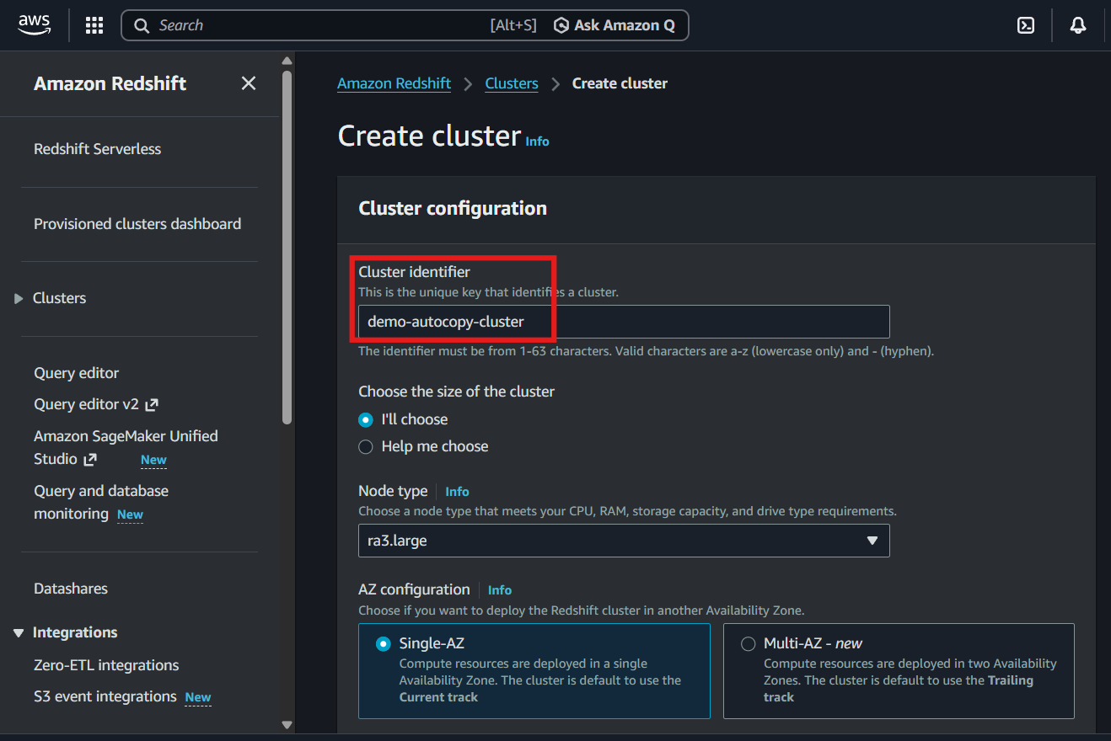
- Select ra3.large as the node type
- Set the number of nodes to 2
- Disable sample data loading
- Keep the default database username
- Click Generate password
- Associate the required IAM roles
  - Default Redshift service role
  - S3 access role (create manually)
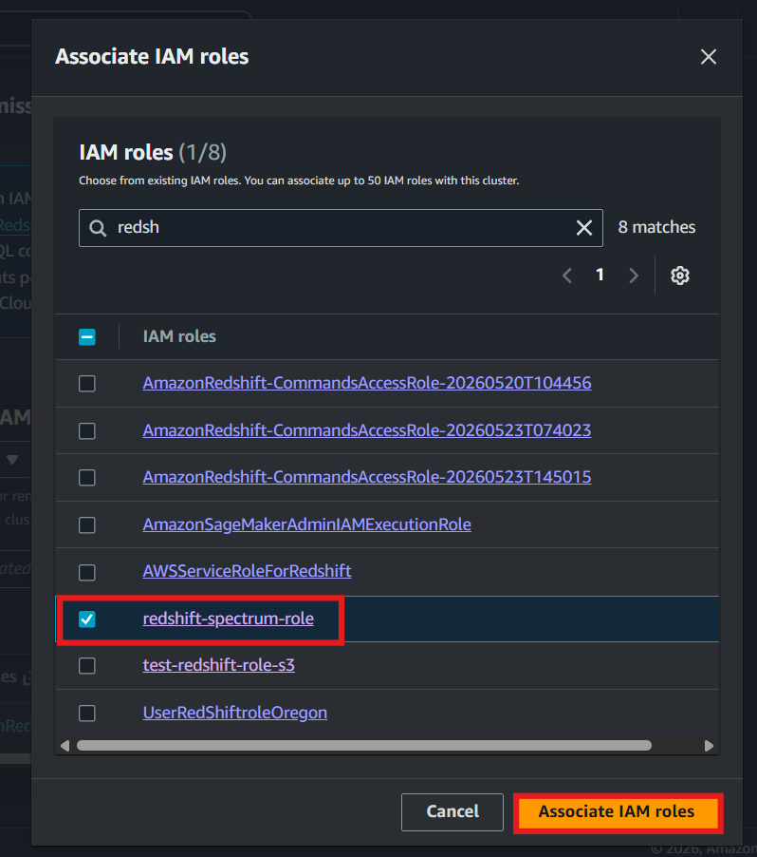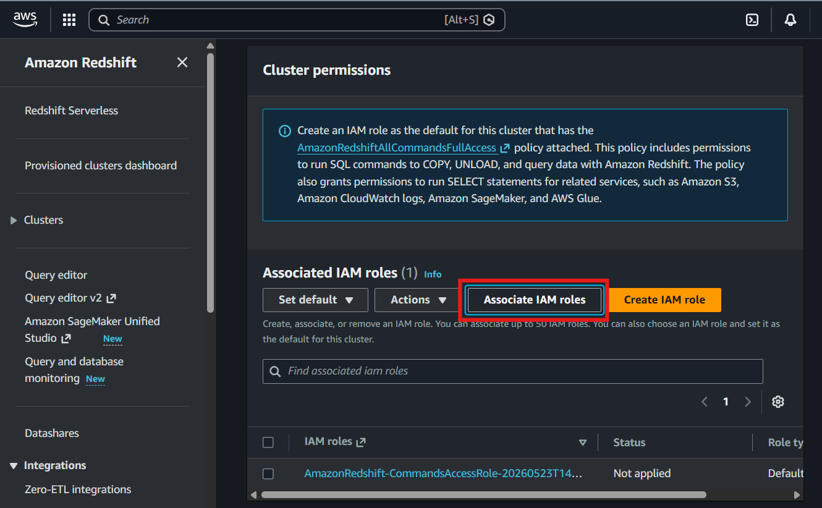
- Select Use defaults for networking configuration
- Click Create cluster
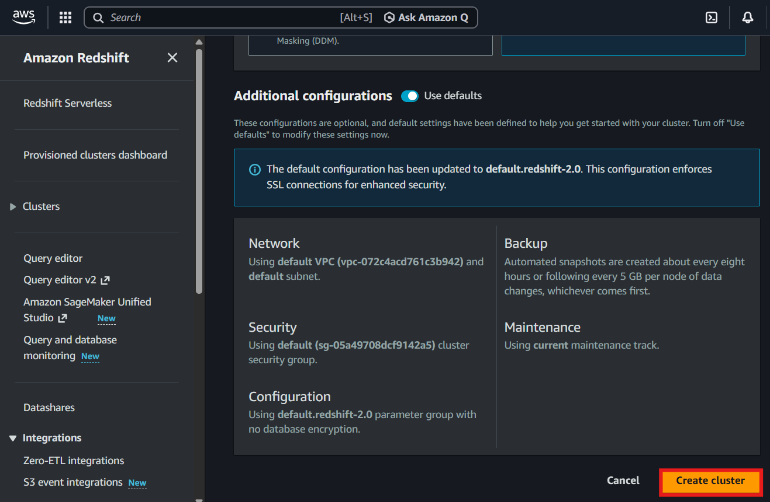
- Wait for the cluster status to become Available
Create the Source Location in Amazon S3
- Navigate to Amazon S3
- Open the bucket used for the lab or create a new one with any name but I am making a new one with qtd-redshift-demo
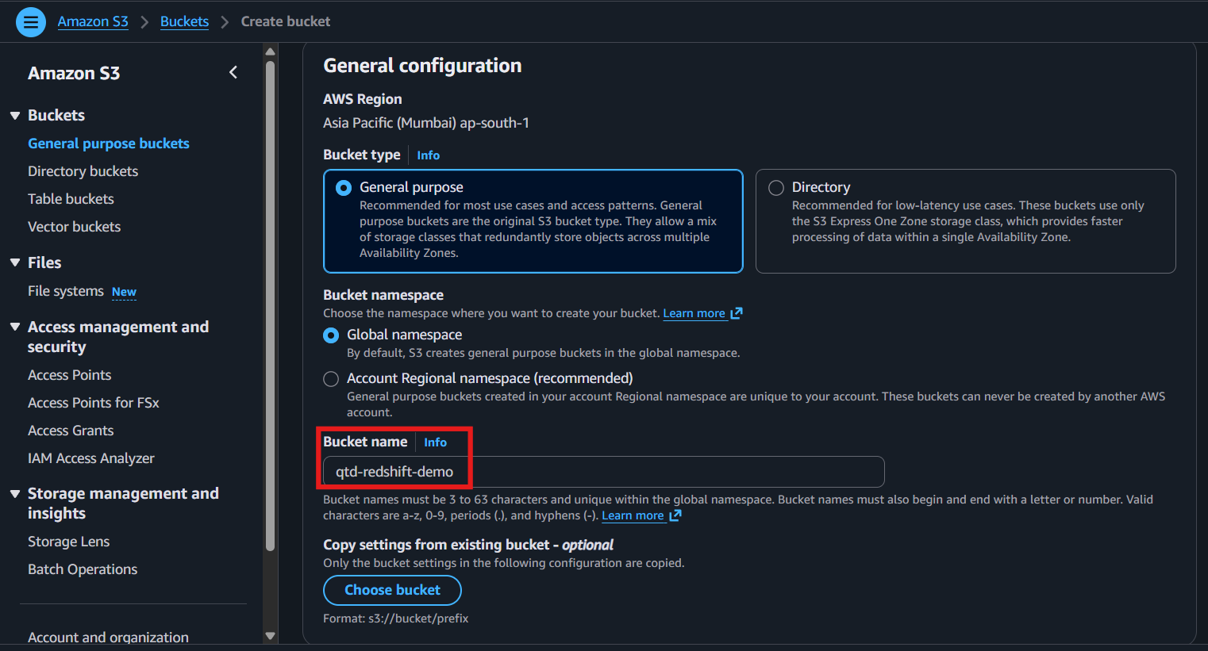
- Click Create folder
- Enter the folder name: auto-copy
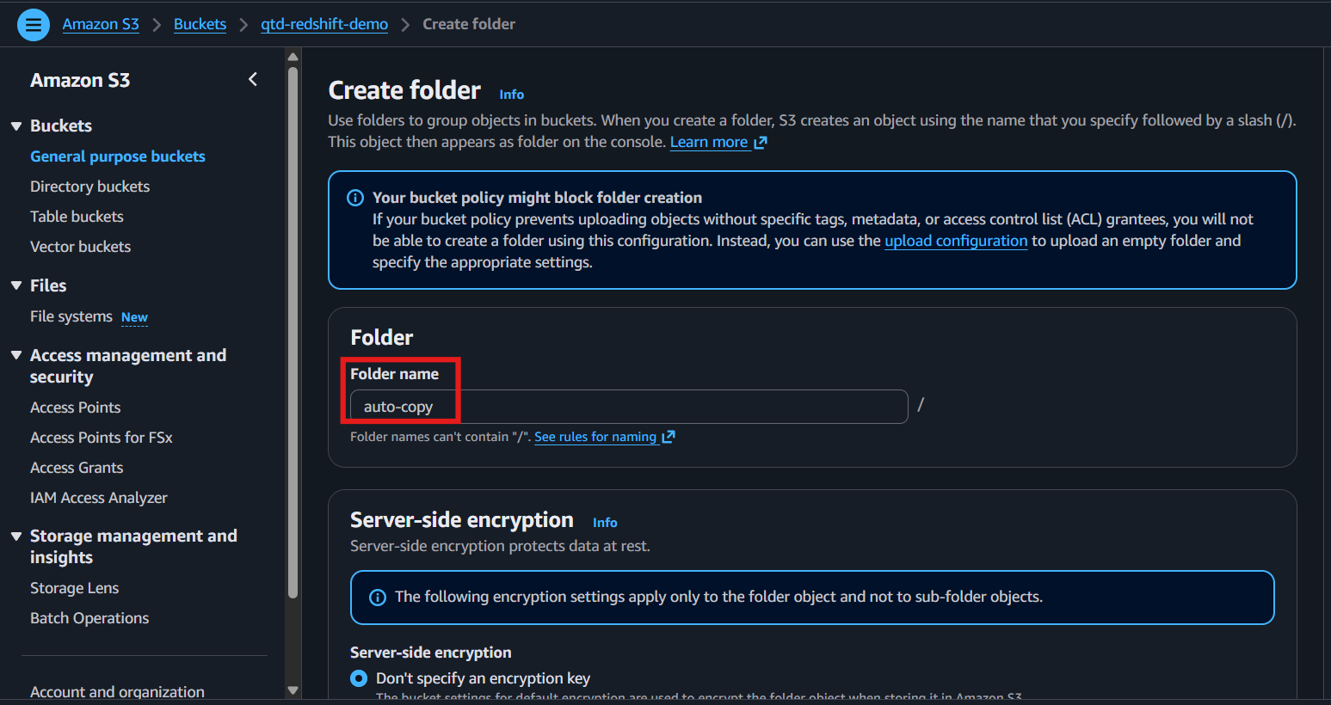
- Click Create folder
- Verify that the folder is created successfully
Connect to Query Editor v2
- Navigate to Amazon Redshift
- Click Query data
- Open Query Editor v2
- Create a connection using temporary credentials
- Select the target cluster
- Click Create connection
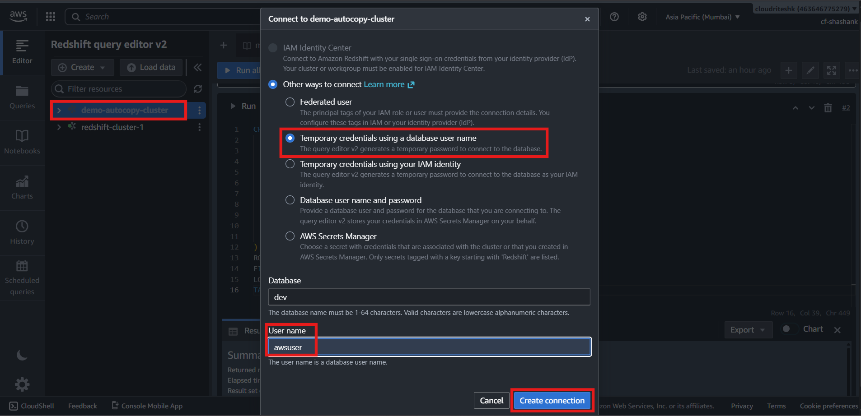
Create the Target Sales Table
- Run the table creation script
CREATE TABLE sales(
salesid integer not null,
listid integer not null distkey,
sellerid integer not null,
buyerid integer not null,
eventid integer not null,
dateid smallint not null sortkey,
qtysold smallint not null,
pricepaid decimal(8,2),
commission decimal(8,2),
saletime timestamp);
- Click Run
- Refresh the database explorer
- Verify that the sales table is created successfully
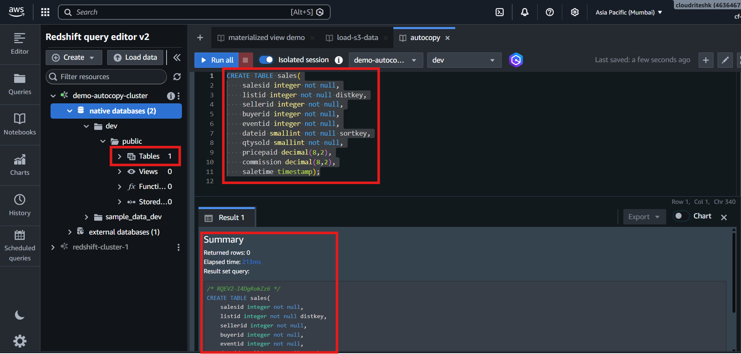
Create the Auto Copy Job
- Create the Auto Copy job using the COPY command with AUTO mode enabled
COPY sales
from 's3://{s3_location}/'
iam_role 'arn:aws:iam::$account_id:role/test-role-redshift-s3'
delimiter '\t'
timeformat 'MM/DD/YYYY HH:MI:SS'
region 'ap-south-1';
JOB CREATE test_auto_copy_sales_job
AUTO ON;
- Click Run
- Verify that the job is created successfully
Verify Job Creation
- Query the auto copy job metadata
SELECT *
FROM sys_copy_job;
- Click Run
- Verify that the job appears in the system table
- Note the generated Job ID
Verify Initial Table State
- Check the current row count
SELECT COUNT(*)
FROM sales;
- Verify that the table contains zero records
Upload the First File
- Navigate to Amazon S3
- Open the autocopy folder
- Upload sales1.txt
- Wait for the upload to complete
Validate the First Auto Load
- Query the auto copy job status
SELECT *
FROM sys_copy_job;
- Verify that the load status is successful
- Check the sales table row count
SELECT COUNT(*)
FROM sales;
- Verify that approximately 60,000 records are loaded
Upload the Second File
- Upload sales2.txt to the same S3 folder
- Wait for the upload to complete
Validate the Second Auto Load
- Check the sales table row count
SELECT COUNT(*)
FROM sales;
- Verify that approximately 120,000 records are present
- Query load history and verify two successful load entries
Upload the Third File
- Upload sales3.txt to the same S3 folder
- Wait for the upload to complete
Validate the Final Auto Load
- Check the sales table row count
SELECT COUNT(*)
FROM sales;
- Verify that approximately 172,456 records are loaded
- Query load history
SELECT *
FROM stl_load_commits;
- Verify that three separate load entries exist
- Verify that each uploaded file generated a separate load event
- Confirm that all three files were loaded automatically without manually executing additional COPY commands
Final Verification
- Verify that the Auto Copy job is active
- Verify that files uploaded to Amazon S3 are loaded automatically into Amazon Redshift
- Verify that system tables record each load operation
- Confirm that Amazon Redshift S3 Auto Copy successfully automates file ingestion from Amazon S3 into Redshift tables.

